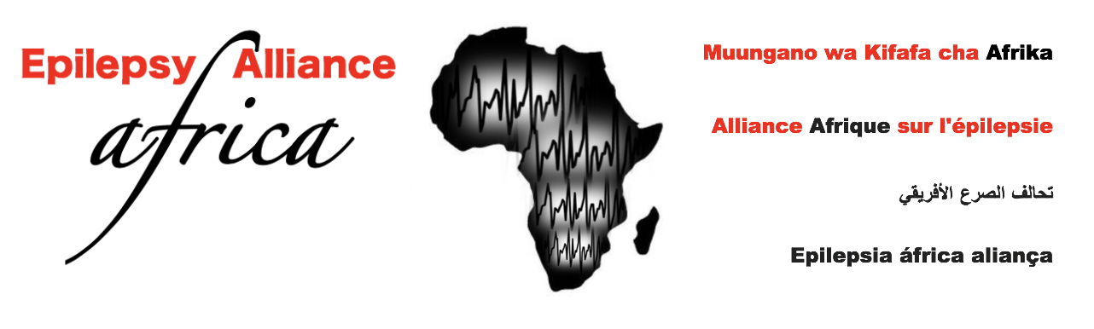**Epilepsy Alliance Africa (EAA)**

**Membership Form**

Thank you for showing interest in Epilepsy Alliance Africa (EAA). EAA welcomes new members at any time. If you are a new or existing association or individual advocates or champions for epilepsy, please contact us for easy registration. Membership fee is US$20 per annum/year. Donations are welcome. Bank details will be provided after submitting this form to [epilepsyallianceafrica@gmail.com](mailto:epilepsyallianceafrica@gmail.com)

|  |  |  |  |  |  |  |  |  |  |  |  |  |
| --- | --- | --- | --- | --- | --- | --- | --- | --- | --- | --- | --- | --- |
| **Name of Association or Individual**  **Registration Number (if available):** | | | | | | | | | | | **Alliancee No:** | |
| **Address:**  **Country:** | | | | | | | | | | | | |
| **Contact person: Title:**  **Signature:** | | | | | | | | | | | | |
| **Email:** | | | | | | | **Mobile:** | | | | | |
| **Phone:** | | | | | | | **Web www.** | | | | | |
| **WhatsApp:** | |  | | | | | | | | | | |
| **Facebook:** | |  | | | | | | | | | | |
| **Twitter:** | |  | | | | | | | | | | |
| **Other:** | |  | | | | | | | | | | |
| **If you are association, society or institution, state your aims** | | | | | | | | | | | | |
| **How many people with epilepsy do you serve/members if you are association, society or institution? : …………………………….** | | | | | | | | | | | | |
| **If you are an association, society or institution, what is your registration/legal status? (**mention if still being formed**)** | | | | |  | | | | | | | |
| **If you are an organisation, what year were you formed/did you start?** | | | | |  | | | | | | | |
| **Membership**  **Types** (please tick) | **Individual** | |  | **Association/Society** | |  | | **Institution** |  | **Partner** | |  |
| **Family** | |  | **Group** | |  | | **Government** |  | **Other………** | |  |
| **Please provide a copy of your logo in this box** | | | | | | | | | | | | |
| **Date applied** | | | | **Date approved** | | | **Signature/s** | | | | | |